CHEMISTRY
Year 12

Practice TEST

Reaction Rates and equilibrium

Name: ____________________________

MC= /15
SA = /40
TOTAL: /55

PLEASE DO NOT TURN THE PAGE UNTIL INSTRUCTED TO DO SO

PART 1 : Multiple Choice

- Which one of the following would NOT cause an increase in the RATE of a chemical reaction?

a) Addition of a catalyst.
b) Increasing the concentration of the reactants.
c) Decreasing the temperature of the reacting species.
d) Increasing the pressure of gases involved in a reaction.

- The decomposition of hydrogen peroxide into oxygen and water proceeds very slowly at room temperature. However, the addition of a small amount of manganese dioxide (MnO₂), causes the hydrogen peroxide to bubble vigorously due to the rapid production of oxygen.

2H₂O_{2(aq)} 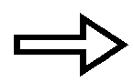 O_{2(g)} + 2H₂O_{(l)} very slow

2H₂O_{2(aq)} 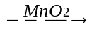 O_{2(g)} + 2H₂O_{(l)} vigorous

The best explanation for this is

a) The manganese dioxide acts as a catalyst, providing an alternative reaction pathway that has a lower activation energy.
b) The manganese dioxide increases the temperature of the reaction thereby increasing the collision rate of the molecules.
c) The manganese dioxide increases the collision rate between reacting molecules simply by causing an increase in the total number of molecules in the solution.
d) The manganese dioxide increases the collision energy of the hydrogen peroxide molecules

- The following diagram shows the changes in Potential Energy for the reaction :
N_{2(g)} + O_{2(g)} 2NO_{(g)}
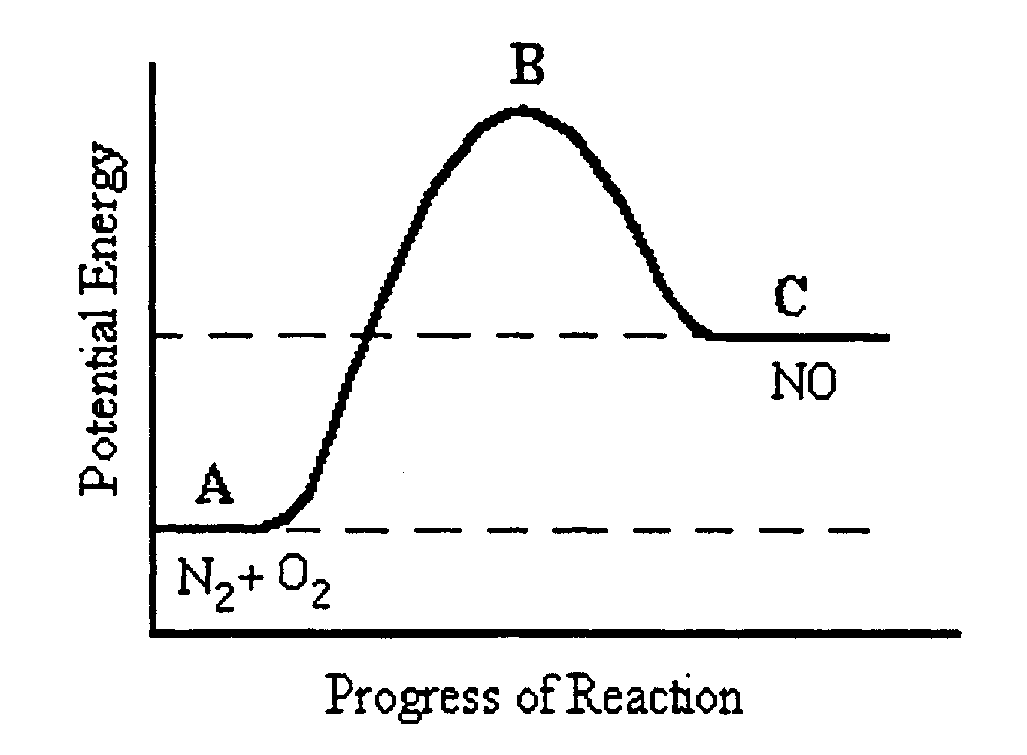

Which of the following statements is FALSE?
a) The reaction is endothermic with ΔH = C – A.
b) The reactants have less potential energy than the products.
c) B represents the transitional state where intermediate compounds are formed in the course of the reaction.
d) The activation energy would be equal to B – C.

- Consider the reaction between marble chips (calcium carbonate) and dilute hydrochloric acid:

CaCO_{3(s)} + 2H⁺_{(aq)} Ca²⁺_{(aq)} + CO_{2(g)} + H₂O_{(l)}

Which one of the following would increase the rate at which the marble chips react?

a) Decreasing the concentration of the hydrochloric acid.
b) Adding more water to the solution.
c) Crushing the marble chips into powder form.
d) Decreasing the temperature of the acid solution added.

The next three questions refer to the information below.

An experiment was performed to measure the amount of oxygen gas evolved at ten second intervals, when 40 mL of hydrogen peroxide was allowed to decompose according to the equation:
_{MnO2}
2H₂O_{2(l)} 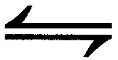 2H₂O _{(l)} + O_{2(g)}

The reaction was carried out at 20ºC and 0.5 g of manganese dioxide added at the start of the experiment. The results are shown in the graph below.
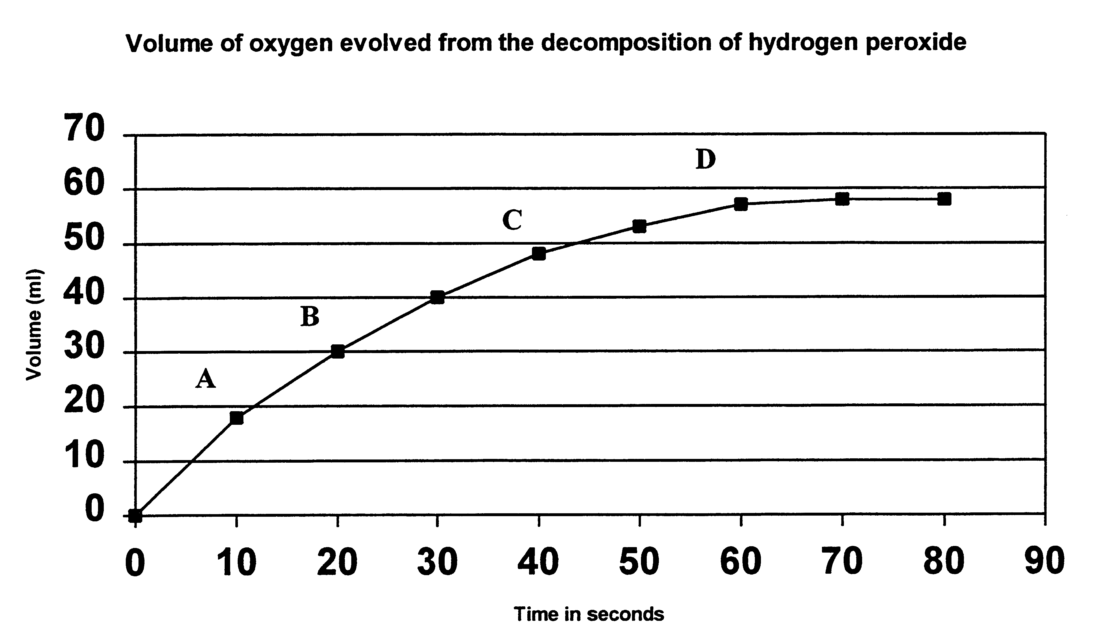

- At what interval is the RATE of reaction greatest?

a) Between 0 and A.
b) Between A and B.
c) Between B and C.
d) Between C and D.

- Consider the following reaction at equilibrium at 1000ºC:

2CO_{(g)} + O_{2(g)} <==> 2CO_{2(g)} ΔH = -556 kJ

Which of the following changes would NOT result in a larger yield of CO₂?

(a) Decreasing the volume
(b) Decreasing the temperature
(c) Adding a catalyst
(d) Increasing the partial pressure of CO(g)

- Which is the correct equilibrium constant for the reaction described in the previous question?

(a) K = [CO₂]
[CO][O₂]

(b) K = [CO]²[O₂]
[CO₂]

(c) K = [CO][O₂]
[CO₂]

(d) K = [CO₂]²
[CO]²[O₂]

- Given the following reaction at equilibrium:

2A_{(g)} + 2B_{(g)} <==> 3C_{(g)} + 2D_{(g)}

At equilibrium, the concentration of each substance is found to be:

[A] = 2M; [B] = 3M; [C] = 3M; [D] = 1M.

The value for the equilibrium constant, K, is which one of the following?

(a) 0.5
(b) 0.75
(c) 1.0
(d) 1.3

THE NEXT TWO QUESTIONS REFER TO THE FOLLOWING REACTION:

4HCl_{(g)} + O_{2(g)} <==> 2H₂O_{(g)} + 2Cl_{2(g)} ΔH = +113 kJ

- To speed up the above reaction, we could:

(a) Increase the pressure
(b) Increase the temperature
(c) Add a catalyst
(d) All of the above

- In order to increase the yield of chlorine, we could:

(a) Decrease the pressure
(b) Decrease the temperature
(c) Add more oxygen to the system
(d) Add more water vapour

THE NEXT THREE QUESTIONS REFER TO THE FOLLOWING EQUATION:

2 SO_{2(g)} + O_{2(g)} <==> 2SO_{3(g)} + heat

This equation represents a gaseous system at equilibrium. Indicate the direction in which the equilibrium shifts when these changes are made:

- The concentration of SO₂(g) is increased:

(a) The equilibrium shifts to the left
(b) The equilibrium will not change
(c) There will be an explosion
(d) The equilibrium favours the product side

- When the partial pressure of SO₃(g) is decreased:

(a) The equilibrium shifts to the right
(b) The equilibrium shifts to the left
(c) The equilibrium shifts does not change
(d) The equilibrium shifts only at very high temperatures

- When the temperature of the system is decreased:

(a) The equilibrium will not change since the heat is applied to both reactants and products
(b) The equilibrium shifts to the right and increases the concentration of SO₃
(c) The equilibrium shifts to the left and increases the concentration of SO₂ thereby increasing the temperature enormously
(d) The reactant side must be favoured according to fundamental principles of Le Chatelier’s Principle

- A firm wishes to make industrial use of the equilibrium:

2CO_{(g)} + 2F_{2(g)} + CCl_{4(g)} <==> CF_{4(g)} + 2COCl_{2(g)} + heat

Which set of conditions offers most chance of commercial success?

(a) High pressure, low temperature
(b) High pressure, high temperature
(c) Low pressure, high temperature
(d) Low pressure, low temperature

- The following reaction occurs in a sealed flask.

CaCO_{3(s)} + 2H⁺_{(aq)} → Ca²⁺_{(aq)} + CO_{2(g)} + H₂O_{(l)} ΔH = -14kJ

It is possible to increase the rate of this reaction by:

(a) Increasing the pressure
(b) Decreasing the pressure
(c) Adding some base
(d) Using finely divided CaCO₃(s)

PART 2: SHORT ANSWER

- (a) Sketch and label a reaction profile for the chemical reaction shown below.
The activation energy is 230kJ mol-1. Sketch the graph to scale.
H₂ _{(g)} + F₂ _{(g)} 2 HF _{(g)} ΔH = - 538 kJ mol-1



- The overall change in heat energy describes this reaction as
an reaction.
(5 marks)

- In the reaction of a fuel cell, 2H₂ _{(g)} + O₂ _{(g)} 2 H₂O _{(l)} a platinum catalyst is used.

- On the graph show the effect of the catalyst on the energy necessary for
the reaction to occur.

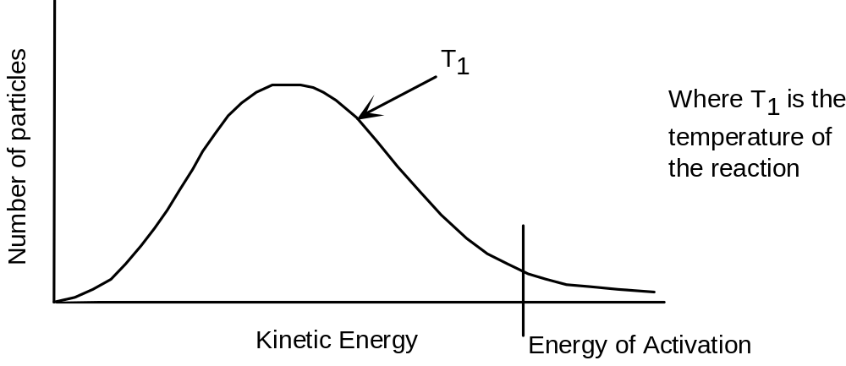

- On the graph, show the effect of increasing the temperature of the system (label this T₂).

(2 marks)

- Nitrogen dioxide, NO₂, is a dark brown gas which exists in a state of chemical equilibrium with the colourless gas dinitrogen tetroxide, N₂O₄.

N₂O_{4(g)} <==> 2NO_{2(g)} ΔH = +58 kJ

At 25ºC a sample of the gases at equilibrium is amber coloured.

- If the temperature is raised to 50ºC, predict the change in colour of the sample.

_________________________________________________________________________

(1 mark)

- Explain, using le Chatelier’s Principle, why this colour change has occurred.
____________________________________________________________________________________________________________________________________________________________

(1 mark)

- Predict what colour change would occur, if any, if the temperature was maintained at 25ºC while the volume of the container was halved.
____________________________________________________________________________________________________________________________________________________________

(1 mark)

- Explain, using Le Chatelier’s Principle, your answer to part (d).
__________________________________________________________________________________________________________________________________________________________________________________________________________________________________________

(1 marks)

- A student prepared a solution of a weak monoprotic acid HA by dissolving 2.0 mole of it in a volumetric flask and making the final volume up to 1.00 L.

- What would the molar concentration of HA _{(aq)} molecules be if it was assumed that no dissociation of HA _{(aq)} occurred?
_______________________________

(1 mark)

- Being a weak acid, partial dissociation of HA _{(aq)} molecules will occur. Write an equation to represent this.

___________________________________________________________________________

(1 mark)

- Write an expression for the equilibrium constant for the equation in (b).

(1 mark)

- When the dissociation equilibrium has been achieved, the concentration of H⁺ _{(aq)} and A⁻ _{(aq)} is 0.5 molL⁻¹ in each case.

- What will be the actual concentration of HA _{(aq)} molecules when equilibrium is achieved?
____________________________

(1 mark)

(ii) Draw a graph to show changes in concentration of HA _{(aq)}, H⁺ _{(aq)} and A⁻ _{(aq)} before and after equilibrium. Make sure you label your axis and clearly distinguish the paths of HA_{(aq)}, H⁺ _{(aq)} and A⁻ _{(aq).}

(4 marks)

- One step in the synthesis of nitric acid from ammonia involves the following reversible reaction.

2NO_{(g)} + O_{2(g)} <==> 2NO_{2(g)} ΔH = -114 kJ

Assume this reaction has reached equilibrium in a closed container at constant temperature and pressure.

- What happens to the equilibrium yield of NO₂(g) if the following occur?
(INCREASE, SAME, DECREASE)

- The volume of the container is increased. ______________________

(ii) More oxygen is added to the container. ______________________

(iii) A suitable catalyst is added. ______________________
(3 marks)

- What happens initially to the RATE of the FORWARD reaction if the following changes are made?
(INCREASES, SAME, DECREASE)

- The temperature of the container is increased. __________________

(ii) More NO₂(g) is added to the container. __________________

(iii) A suitable catalyst is added to the container. __________________

(3 marks)

- The equilibrium between Ca(OH)₂ and its ions in aqueous solution can be represented by the following equation:

Ca(OH)_{2(s)} <==> Ca²⁺_{(aq)} + 2OH⁻_{(aq)}
White colourless solution

At equilibrium, the white solid is present in a colourless solution.
Three test tubes are set up, each containing the equilibrium mixture. Each of the test tubes is treated as described below. In each case state what will be observed, how the equilibrium will shift and what happens to the concentrations of the ions asked about.

What is done? | What is observed? | How the equilibrium shifts? Write  ‘→’,’←’ or  ‘no change’ | What happens to the concentration of Ca²⁺.  Write increase, decrease or  no change | What happens to the concentration of OH⁻ after equilibrium is resestablished.  Write increase, decrease or  no change
A little water is added to the first test tube
A few drops of 1.0 molL⁻¹ hydrochloric acid solution are applied to the second test tube
A little solid sodium hydroxide is applied to the third test tube
(6 marks)

- Concentrations of the three substances in the reaction system:

POCl_{3(g)} POCl_{(g)} + Cl_{2(g)}

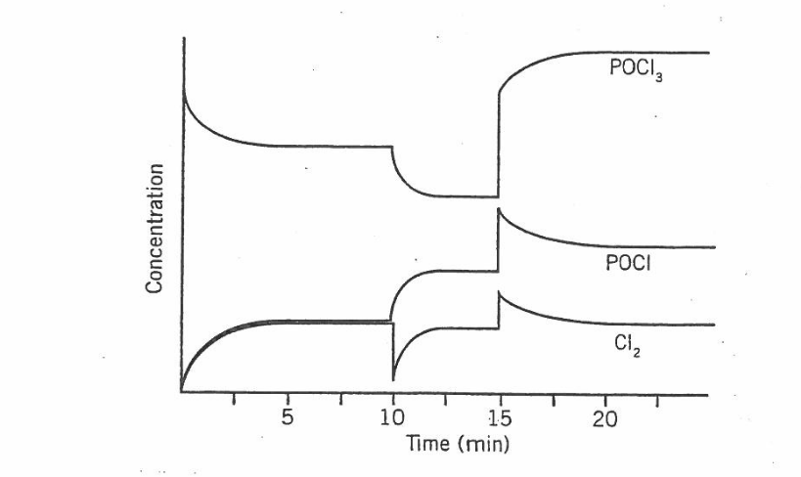
are shown in the graph below.

- What substance, or substances, was/were initially introduced into the reaction flask at the beginning of the experiment?
_________________________________________________________________________
- What is shown by the horizontal section of the graphs between 5 and 10 minutes?
_________________________________________________________________________
- Suggest what might have been done to the system at the 10 minute mark.
_________________________________________________________________________
- At about what time did the system again reach equilibrium after this first change in conditions?
_________________________________________________________________________
- Suggest what might have been done to the system at 15 minutes.
_________________________________________________________________________
- What was the immediate effect on the concentrations of the substances when the change occurred at 15 minutes?
________________________________________________________________________
- In which direction did the equilibrium position move to again reach equilibrium after the change at 15 minutes?
_________________________________________________________________________
- If a catalyst was added at 23 minutes, in what way would the graphs change? Justify your answer.
___________________________________________________________________________________________________________________________________________________________________________________________________________________________
(9marks)

